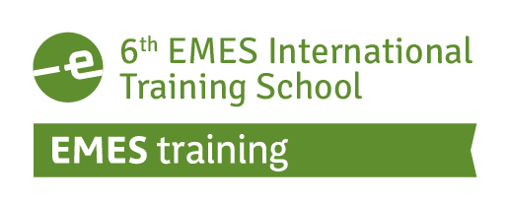

6th EMES INTERNATIONAL TRAINING SCHOOL

Social enterprises and research methods:
Qualitative methods, mixed methods
and international comparisons

19 – 22 June 2018 · Marseille, France

Organised by:
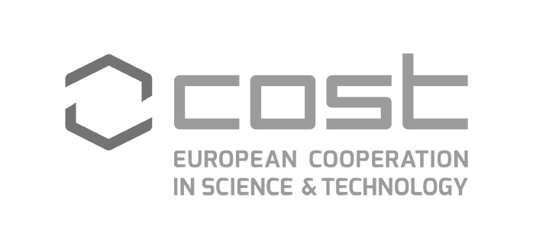
Action 16206 “Empowering the next generation of social enterprise scholars” (EMPOWER-SE)
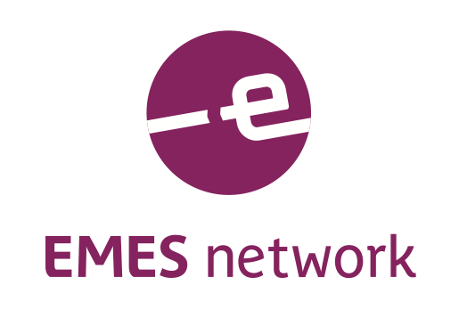

APPLICATION FORM

INSTRUCTIONS (please read carefully):
Applications to the 6th EMES International Training School will be assessed on the basis of the information provided in this form, which contains three sections. We therefore advise you to complete this form thoroughly. Please provide the required details but do not include any additional document.
In sections 2.5 and 2.6, please respect the word limits set. If needed, we may request you to provide documents proving any information included in this application.
The completed application form should be submitted as A SINGLE Word or PDF document to be uploaded on the 6th EMES Training School platform.
Application deadline: 22nd January 2018

Section 1: PERSONAL DETAILS (IN BLOCK LETTERS, PLEASE)

Title | Family Name/Last Name:

Given Name/First Name: | Male/Female:

Date of birth (day/month/year): | Nationality: | Special needs (i.e. dietary or mobility requirements):

Correspondence address: | Email address:
Correspondence address: | Telephone number (with international code):

IN CASE OF EMERGENCY PLEASE CONTACT:
Name
Street / Street No
Postal Code / City / Country
Tel. / Fax / Email

Section 2: GENERAL AND ACADEMIC INFORMATION

2.1. HOW DID YOU HEARD ABOUT THE 6th EMES INTERNATIONAL TRAINING SCHOOL?

EMES web, social media or news alert  Direct contact with the organisers  University | Friends/Previous students/Colleagues  Other (please specify):  _________________________________

2.2. CURRENT UNIVERSITY
University name
Department/School
Address
Research area(s)
Year of study
Thesis advisor

2.3. SUMMARY OF EDUCATIONAL BACKGROUND
 | Degree type | Field(s) | Result | Date of award
UNDERGRADUATE
GRADUATE

2.4. ACADEMIC CURRICULUM VITAE
(Please insert the necessary text here – Do not send a different document. Max. 1500 words)

2.5. THESIS OR RESEARCH PROJECT DESCRIPTION
(Please provide a summary of your research project including a problem statement and research questions, theoretical framework, research methodology, and expected contributions: 1300-1500 words)

2.6. THESIS OR RESEARCH PROJECT STATE OF ADVANCEMENT
(Please explain where you are currently with regard to the plan stated above: have the research questions and review of literature been achieved? What about the collection and treatment of data? Any preliminary conclusions? 500-700 words)

2.7. MOTIVATION LETTER
(Please explain why you are interested in participating in this summer school and what you expect from it: 300-500 words)

Section 3: ADDITIONAL INFORMATION

3.1. REGISTRATION OPTIONS
The 6th EMES Training School offers four registration options, depending on the country of origin of the applicants and whether the participant is a member of EMES:

 | EMES Members * | Non-EMES members
Full registration fee | 655€ | 725€
Reduced registration fee ** | 405€ | 475€

* Participants registering under this fee will need to provide proof of membership (username).
** Only for applicants coming from non-OECD countries in Africa, Asia and Latin America.

If you need an invoice, please contact us with all the payment details so we can send it to you.

3.2. GRANT OPTIONS (for accepted applicants)

The organizers of the Training School may offer a limited number of grants from the EMPOWER-SE COST Action and registration reduction to non-OECD countries from Africa, Asia and Latin America. Candidates applying for scholarships will be selected by the scientific committee on the basis of their academic merit and on whether the application meets the specific objectives described in the EMPOWER-SE Memorandum of Understanding (page 3-4). Moreover, the following specific COST criteria apply: gender balance, ITC origin and ECI stage.

Please select the option (A, B o C) most suitable to you:

A | I am interested in being considered for the EMPOWER-SE COST Action full grant support (please complete):
  Gender: | ITC origin? | ECI stage?
    Male
    Female
    Yes
    No
    Yes
    No
B | I am from a non-OECD countries from Africa, Asia and Latin America and am interested in a registration reduction.
C | I do not require grant support.

Since available funding is limited, please think about possible available funding sources near you so other researchers needing it may benefit. In addition to your university department, you could try local foundations or research institutes. Keep in mind that you may need to be creative and proactive and that we can support you with a support letter to support your funding request.

The working language of the Training School will be English.

By signing this document, I hereby certify that the information provided in this application form is accurate.

Date and place: Signature (required):

PLEASE UPLOAD THIS FORM BY 22nd January 2018 on to the 6th EMES Training School platform.

IMPORTANT DATES :
Application submission deadline: 22nd January 2018
Results of the selection process: 26th February 2018
Registration deadline: 9th April 2018
Arrival of participants: 19th June 2018

Inclusiveness Target Countries (ITC) are Bosnia-Herzegovina, Bulgaria, Cyprus, Czech Republic, Estonia, Croatia, Hungary, Lithuania, Latvia, Luxembourg, Malta, Montenegro, Poland, Portugal, Romania, Slovenia, Slovakia, the former Yugoslav Republic of Macedonia, Republic of Serbia and Turkey.
Early Career Investigators (ECI) are researchers with PhD plus a maximum of 8 years of experience.

